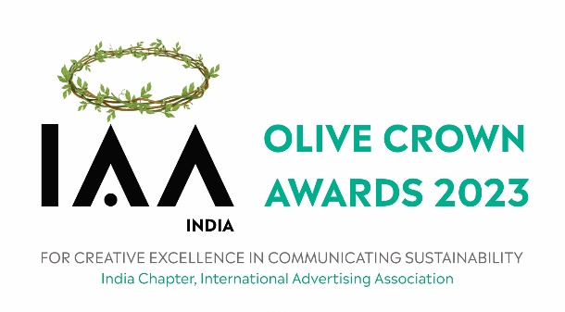
Walking the Talk, we are not accepting any physical entry forms/work display, kindly read the preamble before filling the form

The IAA Olive Crown Awards does not have an entry fee and is open to both agencies and brands.

Entries can be sent in English or Hindi. In case of other languages, the entrants need to send English translations for print and English Subtitles for film.

Entry Deadline: 15th February, 2023

Category Details
The categories are as follows:
1. Press - Consumer Products
2. Press – Services
3. Press – Corporate
4. TVC / Cinema - Consumer Products
5. TVC / Cinema – Services
6. TVC / Cinema – Corporate
7. Digital
8. Events
9. Out-Of-Home
10. Radio
11. Print Production
12. Press – Unreleased
13. TVC / Cinema – Unreleased
14. Young Green Writer of the Year
15. Young Green Art Director of the Year
16. Green Brand of the Year
17. Green Campaign of the Year
18. Green Advertiser of the Year
19. Green Agency of the Year
20. Corporate Social Crusader of the Year
21. International Green Campaign of The Year
22. Green NGO of the Year
23. New Age Green Initiatives
Category 12 & 13 - This is for the creatives, which have not been released. In the event that
the same work is released later by a brand or a corporation, the work will be eligible for entry next year as well.

Category 14 & 15 - This category is for professionals who are 30 years old or less
(as on Dec 31, 2022). The entrant must present a body of work which has been done for the
cause that the IAA Olive Crown Awards stand for. Any number of work may be entered, unreleased work may also be submitted (please note: the same unreleased work may also be submitted in categories 13 & 14 but with a separate entry form). While it is not mandatory to present work representing multiple media, one must bear in mind that an entrant presenting a healthy mix may have a natural edge over others who don’t.

Category 16 - Entries for Green Brand of the Year should include the following:
A note, not exceeding 1000 words explaining the objectives of the campaign with a
perspective of the sustainability issues that were sought to be addressed, the creative
concept, the media mix used, any unique methods used in the communication, the budget
and an assessment of the impact it made. Print and photographic annexure validating the
effort could be attached.

Category 17 - Entry must be a multimedia campaign which has appeared in a minimum of
two vehicles. The number of entries forming a campaign must be a minimum of four.
E.g.: Three press single and one TVC single.

Category 18 & 19 - No entries can be sent. These Awards will be for the cumulative points
won by the agency / advertiser.

Category 20 - A one-page note should be submitted detailing the nature of the Corporate
Social Investment initiative, its objective, its duration, its reach within the community, its
impact as perceived and measured by you.
Category 21 – Entries should be submitted along with translations into English to facilitate the judging process.

Category 22 – Entries should provide details of the scope of work, place of work, number of beneficiaries, and should be relevant to the green space. The entry should be in the form of note not exceeding 500 words & photographs or creative material which highlights the work done.

Category 23 - A green first initiative/organization working in the space to reduce/minimize/manage things that cause harm to the environment by creating a positive change.
Submit a 500 word note on the vision behind the initiative/organization.
Tell us about the objective, age, scalability and the impact you have created so far. Do include testimonials of your work, any media recognition, client speak, etc.
This is specifically aimed at new age green initiatives which provide their services to companies, events and the like.

Eligibility: Entries should have been released (or held) between January 1, 2022 and
December 31, 2022.

- Should conform to the guidelines of the Advertising Standards Council of India (ASCI).
- Should not have been created mainly for the purpose of winning an award.
- Should not be exercises in “green-washing”.
- The organizers reserve the right to reject entries which could be seen as offensive to
national, religious or public sentiments or taste.
Awards: In each category the jury will award a Gold and Silver Olive Crown to the winning
entries (Winner, Runner-Up). These awards will be conferred on the entrant companies.
In case an entry is submitted by more than one entrant, the organizers will bring it up to both parties at an appropriate time – only one entrant per entry will be accepted.

Material:
- All campaign material (excluding videos) to be uploaded on a SINGLE google drive folder and shared
- Videos to be uploaded on YouTube as unlisted and the link of the same to be shared. Incase of multiple videos, all must be added to a playlist and the relevant links to be shared

- URL Link for submitting entries: https://ocawards.awardor.com/

For any further details, contact:
Soumen Santara
Executive Secretary
India Chapter of International Advertising Association
Unit No. 308, Naman Midtown, B Wing Premises Co-operative Society Ltd.
Senapati Bapat Marg, Elphinstone Road, Prabhadevi
Mumbai-400013
Email: execseciaa@gmail.com
Mobile: 9819980202

